**COMSATS UNIVERSITY ISLAMABAD**



**INFORMATION & COMMUNICATION TECHNOLOGY**

**PROJECT REPORT**

**RESTURANT MANAGEMENT SYSTEM**

* **Submitted By:**

**Omer Muhammadi FA22-BDS-029**

* **Submitted To:**

**Ma’am Hufsa Mohsin**

* **Date of Submission:**

**November 17, 2022**

**RESTAURANT MANAGEMENT SYSTEM**

* **Background:**

The businesses in restaurants are growing constantly. At the same time, the need for managing its operations and tasks arises. The best way to optimize these activities is growing the business online as well. With the improvement of technology, online food ordering systems are becoming a popular topic. That's because they are serving the ever-increasing demand for convince.

With a website or mobile app, customers can **easily browse all the dishes** the restaurant has available, **customize dishes** to their requirements and **place an order**. It can also save their favorite orders allowing them to easily re-order that in the future.

From the restaurants perspective, they **no longer spend time taking the customers order**, **stop worrying about communication errors** and streamline their order management workflow.

* **Motivation:**

We both basically wanted to make a simple code in which we could implement all the main and required topics. So, we chose Restaurant Management/Online food ordering system.

The project “Restaurant Management System” is implemented to reduce the manual work and enhances the accuracy of work in a restaurant. Hence the project is developed proficiently to help restaurant and costumer both.

***Here are the advantages of online delivery services:***

* It makes the **ordering process faster and easier**
* It provides an efficient system for **order and customer management**
* It offers **real-time monitoring** of orders
* It presents a **hassle-free and more cost-effective** option
* It keeps **physical contact to** a minimum

Also, one of our friend (Abdullah) wants to set up his own restaurant and it’s our deal that we are gonna make him online site for his restaurant.

* **Project Overview:**

This program is for MCDONALDS RESTAURANT

* This program is for owner and costumer both and we can decide by selecting an option that either we are owner or costumer.

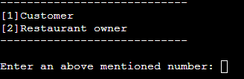

1. **For Costumer:**

* The project includes a **menu of available dishes** from the restaurant. The costumer can see the menu with dishes and their prices.

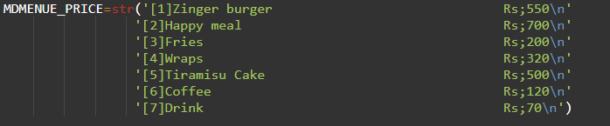

* Then we have **login options**. We have to enter **Name** and **Password**.

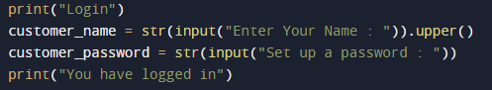

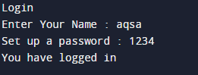

* Then we have to **select item** from the menu any and its **quantity** too.



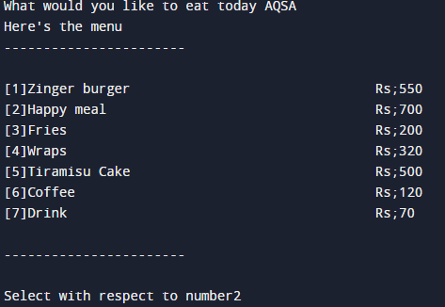





* Then the program asks the user to enter **delivery address** and **method of payment**.

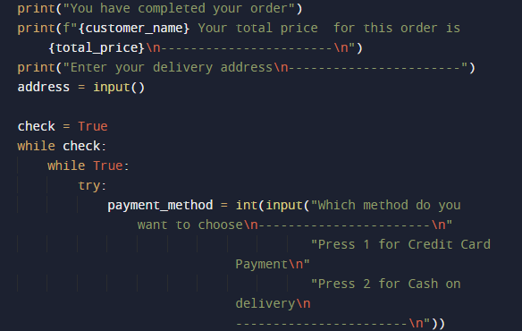

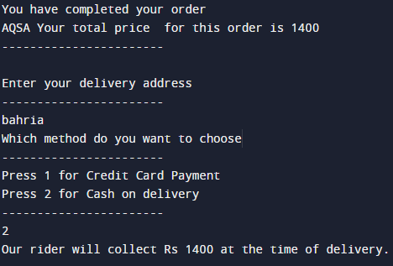

* In the end the user can see the **final receipt**.

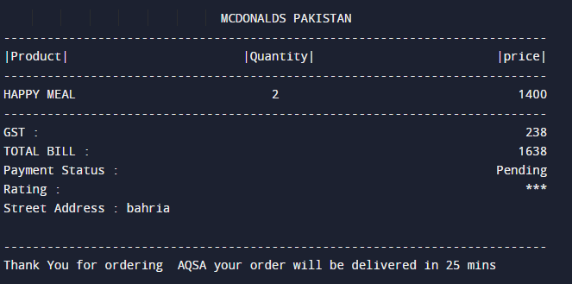

We have developed a RESTAURANT MANAGEMENT SYSTEM with GST calculation in the bill.

1. **Restaurant Owner:**

On the backend, the project includes **admin panel** that allows restaurant owners to manage their menus.

* First the program asks for login information.

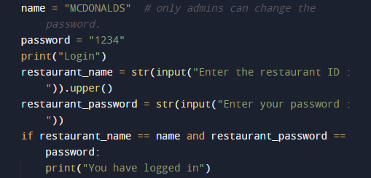

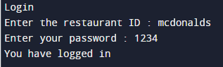

* user can then see 3 option from which he has to select any one .

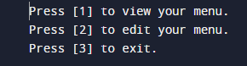

* By pressing 1 user can see menu. By pressing 3 user can exit program. And by pressing 2 user can edit the menu and can see the following options.

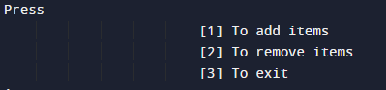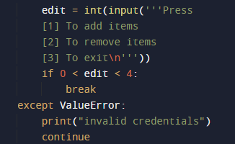

* By pressing 1 owner can **add any product**.

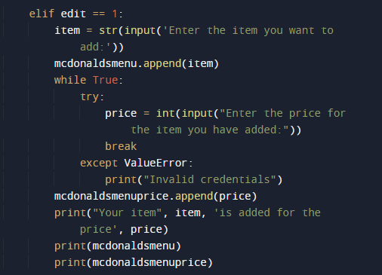

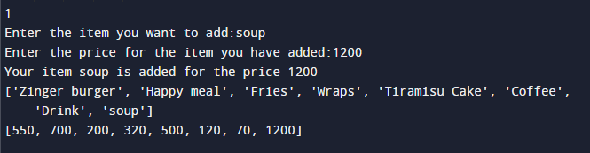

* By pressing 2 owners can **delete any product**.

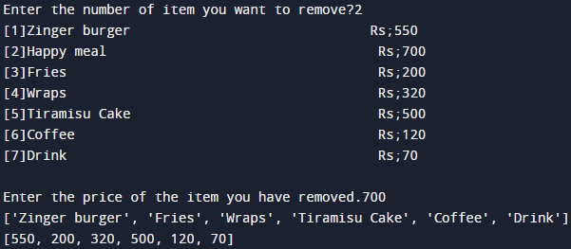

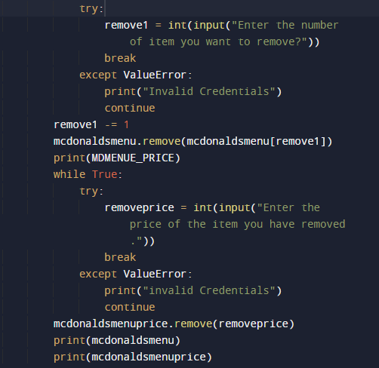

* **Snapshots:**

Following are the main topics we’ve implemented in this program.

1. **Defining functions (user defined functions):**





1. 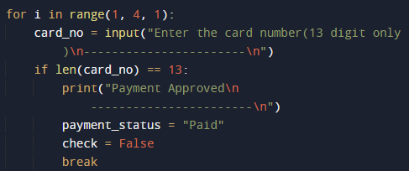**Loops (for and while):**

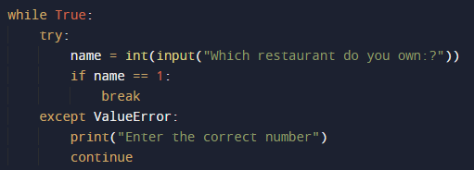

1. **Conditions:**

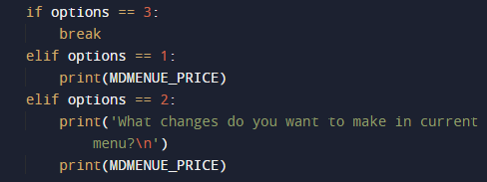

1. **Break and Continue:**

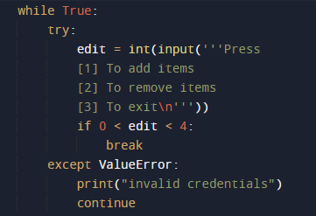

1. **Append function (built in):**





1. **Remove function:**





1. **(. ljust), (. center) and (. rjust) are built in function:**

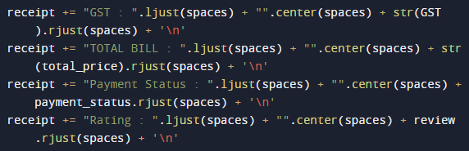

* **Targeted audience:**
* Customers will appreciate it because **it allows them to place orders quickly and easily anytime they want**.
* They can also rest assured that when they place their orders, there will be no misunderstandings.
* An online food ordering solution for restaurants can do wonders for you.
* **Flow chart:**

